The literature landscape on 1.5°C Climate Change and Cities

*William Lamb1, Max Callaghan1, Felix Creutzig1,2, Radhika Khosla3, Jan Minx1,4*

*Affiliations*

*1 Mercator Research Institute on Global Commons and Climate Change, Torgauer Str. 14, 10829 Berlin, Germany*

*2 Sustainability Economics of Human Settlements, Technical University Berlin, Str. des 17. Juni 135, 10623 Berlin, Germany*

*3 Centre for Policy Research, New Delhi 110021, India*

*4 Hertie School of Governance, Friedrichstr. 189, 10117 Berlin, Germany*

*\* Corresponding author: [lamb@mcc-berlin.net](mailto:lamb@mcc-berlin.net)*

*Abstract. Cities are key for implementing ambitious climate goals such as the 1.5°C target of the Paris Agreement. But in times of an exponentially growing literature, the appropriate selection of the urban research for assessments is no longer obvious. Employing methods from computational linguistics, we gain a systematic overview of transport, urban form, buildings, and waste management – each of which play important time-sensitive roles for meeting the 1.5°C target in cities. The epistemic core of this urban mitigation literature is currently focused on urban form, despite extensive research into demand-side options such as congestion charging, parking prices, active travel provisioning, building construction height, and behavioral aspects of energy use. To achieve 1.5°C, all such city-scale options need to be examined.*

# Introduction

To inform the global stock-take of the Paris Agreement, the Intergovernmental Panel on Climate Change (IPCC) has been tasked with a Special Report (SR) to comprehensively assess the state of scientific knowledge on the 1.5°C temperature goal. While the discussion on the 1.5°C goal so far has emphasized the role of negative emissions, as well as the higher economic costs for staying within tight and fast dwindling emission budgets [1–4], it has been largely neglected that 1.5°C policy pathways also come with a distinctively different (gross) CO2 emissions profile compared to 2°C; namely even deeper emissions reductions in the medium-run and long-run, as shown in Figure 1. Cities have a self-evident role in reaching this goal: to leverage their position as the locus of human activity in order to put in place low-carbon infrastructures globally [5].

Cities as infrastructure hotspots are critical for shaping long-run emission trajectories, providing both opportunities for leapfrogging, and risks for emissions lock-in [5–8]. In the wake of slow national progress in climate action, they have emerged as one of the more ambitious policy communities in global climate change governance, despite real problems in assessing their actual performance to date [9]. Nevertheless, cities and local governments with their direct leverage over significant emission components are increasingly recognized as important building blocks for organizing ambitious climate policies in a multi-level governance system [8,10,11].

Despite being highlighted as a mitigation response topic in the SR [12], cities have been staggeringly absent from the discussions on the 1.5°C so far. This is related to the fact that urban infrastructures are not represented in global climate change mitigation models [3], as highlighted for energy end-use technologies in buildings [13] and urban transport [14]. The literature on cities is also largely place-based and does not relate directly to any global temperature target, even though the literature is moving in this direction [15,16].

Yet two even more fundamental challenges threaten the exclusion of urban literatures in upcoming IPCC reports: first, like in other fields of climate change research, the body of relevant literature is large and fast-growing. Minx et al. [17] estimate that the quantity of new peer-reviewed research (as recorded by the ISI Web of Science) published during the sixth assessment cycle is roughly equal to the size of the entire climate change literature before AR6. This trend renders the task of tracking scientific progress increasingly impossible for individuals to manage, even in highly specialized fields, risking bias and systematic omissions in the selection of literature for assessments.

Second, despite recent progress [18], urban climate change assessments are still in their infancy. The available literature has not yet been aggregated into discrete bodies of knowledge that can be easily drawn upon, further risking their exclusion in an already overwhelming field of climate research. Not least, we still lack a basic understanding of the urban contribution to global emissions and the drivers thereof [11,19–21].

To enable a more transparent assessments of the role of cities in climate change mitigation, and to advance discussions in urban climate change research, the relevant literature base needs to be characterized to answer key questions: What part of the urban literature should actually be considered in the upcoming special report? What are the epistemic communities that drive this growing urban literature? And how can it be organized around a coherent set of objectives and policies in the short, medium and long-term?

As a first step towards addressing these issues, this paper systematically identifies the relevant literature on cities and climate change, and analyzes the state and evolution of the research field in terms of its thematic structure as a corner stone for the upcoming special report on the 1.5°C goal. We build a transparent and reproducible search query based on our understanding of the urban literature, focusing on urban mitigation measures and policies related to transport, buildings, waste, and urban form. We apply topic modelling [22] to endogenously define the thematic structure of the literature corpus identified. A variety of other scientometric methods are used to characterize the research field, highlight gaps in our understanding, and provide useful resources for the urban climate change mitigation community.

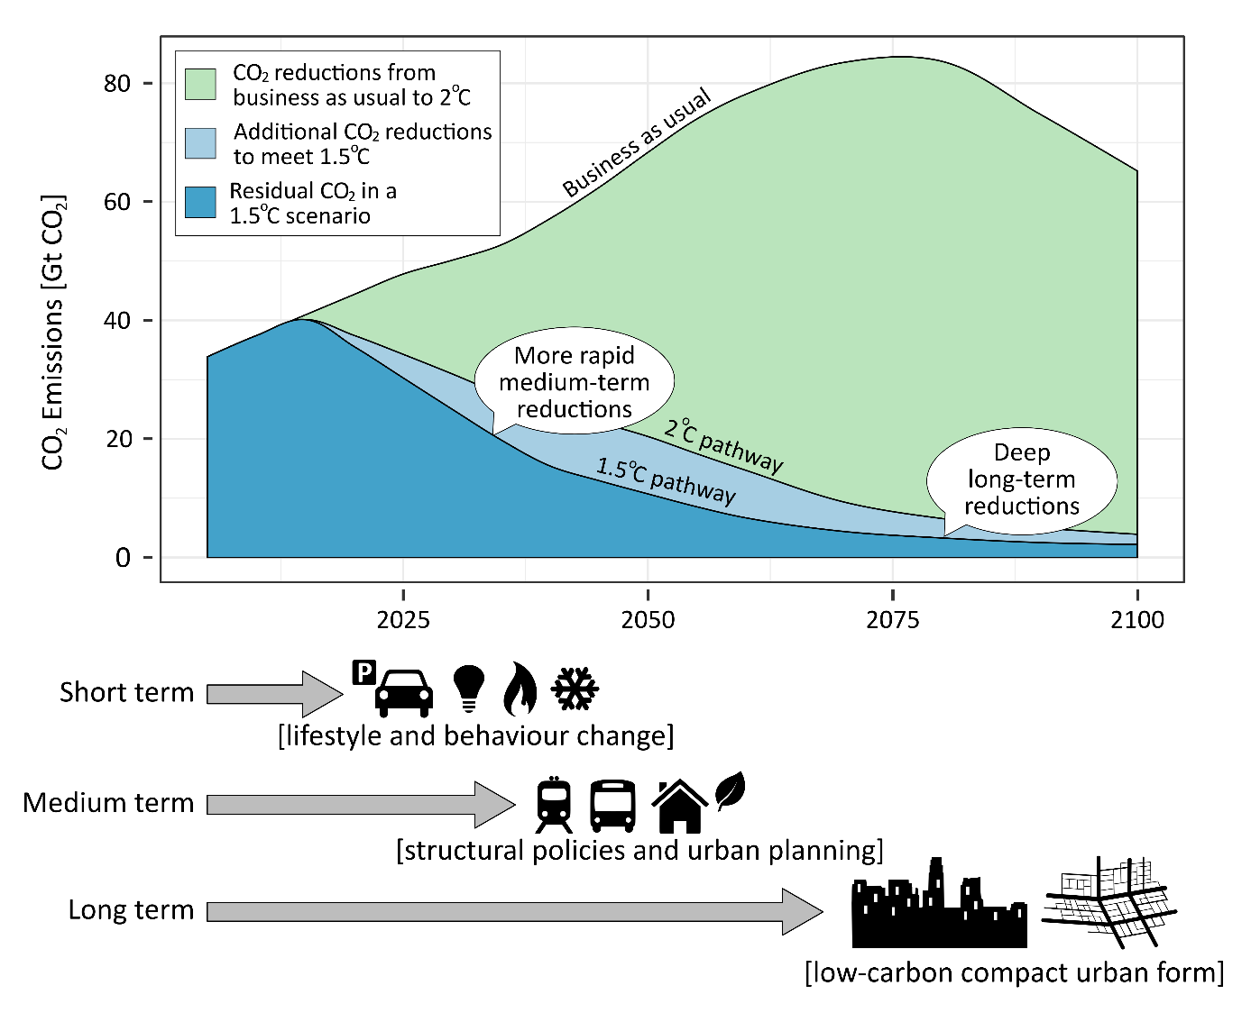

**Figure 1: Initiating an immediate structural shift towards low-carbon urban infrastructure is key for achieving 1.5°C, as compatible pathways are characterized by more rapid CO2 emission reductions and an even lower residual CO2 emissions than 2°C.** Depicted are gross emissions pathways for two REMIND scenarios with full technological availability and emission reductions starting in 2020 [1]. The 1.5°C scenario has a probability of not exceeding 1.5°C in 2100 of 0.74 and a probability of not exceeding 1.5°C throughout the century of 0.48. The corresponding probabilities for 2°C scenarios were 0.83 and 0.8. Not shown are the negative emissions required to stay within the relevant CO2 emission budgets and meet these targets: which total 146 Gt for the 1.5°C scenario and 124 Gt for the 2°C scenario. Note that this graph does not consider the relevant non-CO2 greenhouse gases and their development over time.

# Delineating the urban mitigation literature

Arguably, an urban mitigation assessment should focus on the demand-side of energy consumption and its associated climate impact. Although supply-side activities such as power generation also take place within cities, they are well captured by other research communities (in particular, integrated assessment modelling). By contrast, the demand-side of climate change mitigation has received less attention in climate assessments (but see [23]), and is a natural point of focus for an assessment of urban systems: not only are the everyday practices and uses of energy highly influenced by the shape, structure and organization of cities [24–26], but the majority of energy consumption in the 21st century is projected to take place within them [9,11,27,28].

Four key domains of literature can shed light on the urban drivers of greenhouse gas emissions, and opportunities for their mitigation: transportation, buildings, waste management, and urban form (Figure 2). Urban form captures aspects of both transport and buildings but is distinct in addressing layout and wider systemic effect at larger spatial scales.In the context of the 1.5°C target, these domains play varied roles along different timescales (Figure 1). Understanding these time scales is crucial for advancing urban contributions towards net zero emission trajectories.

In the short-term, lifestyle and behavioral options can contribute most to climate change mitigation. This involves changes in preferences, habits, and decision-making, such as telecommuting, adapting to different room temperatures, food waste reduction, and so forth. These have been reviewed in literatures on the urban transport sector [14,26,29–31], the building sector [32–35], food waste [36], and the overall demand-side [23].

The middle and long-term is dominated by capital and infrastructure stocks [37]. Many options are situated in the buildings sector, including more efficient consumer appliances, heating and cooling systems, and building envelope design and materials. However, they must be fostered now to achieve notable results in 5-10 years. Similarly, the long life-time of road and rail-based systems (40-75+ years) means that the transition towards sustainable transport systems must be implemented now to enable deep decarbonization pathways within 20-40 years. These systems provide important network externalities that will enable the realization of low-carbon compact urban form towards the end of this century. Both empirical and analytical urban economic literature emphasize the role of fuel prices in shaping urban form and the balance of different transport systems [16,38,39].

To transparently identify the urban mitigation literature covered by these four domains, we develop a structured search query for the Web of Science (WOS) literature database. This includes specific combinations of keywords for each domain (e.g. “bicycle infrastructure provisioning”), as well as more generic strings (“low-carbon transport”). Refer to the Supplementary Materials for the full search methodology, and the supplementary data file for the resulting list of documents. We use a form of automated content analysis called non-negative matrix factorization to identify latent topics within the document abstracts we obtain, enabling us to quickly digest the major themes of this work so far.

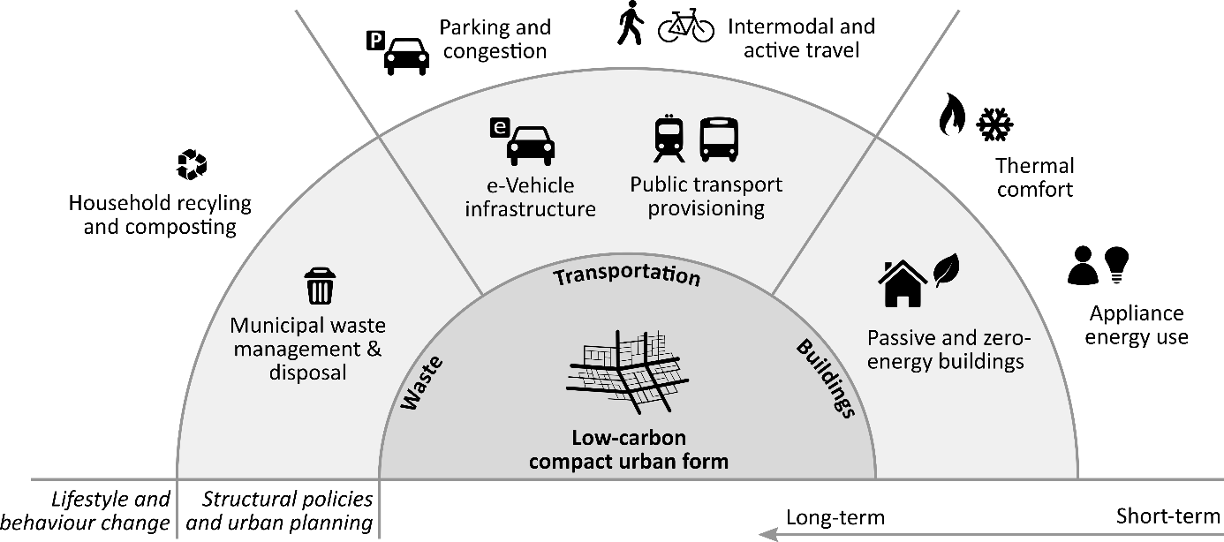

**Figure 2: Scope of the urban mitigation literature, including measures that address urban transport, buildings, waste, and urban form.** Note that neither supply-side energy and material production, nor a broader set of infrastructures and services are included within the scope, since the former is assessed in other mitigation communities, and the latter is more appropriate for an assessment of sustainability, rather than climate change mitigation.

# The structure and content of urban mitigation research

The results of our search query indicate that the urban mitigation literature is substantial (8,120 publications) and fast growing (20.5% per year; see Supplementary Materials Figure 1). Already more than 3000 studies have appeared since AR5 (2008-) and have therefore not been assessed by the IPCC directly or indirectly. Whereas a basic query for urban mitigation literature (e.g. combining synonyms for “urban”, “mitigation” and “policies”) results in only 610 publications, our structured search for papers related to buildings, transportation, urban form and waste yields substantially more (and relevant) papers (8,120).

25 latent topics in this document set are identified by the topic model, described in Table 1. The largest topic – planning and governance (#1) – well represents the policy and planning aspects of urban mitigation that were an explicit condition in our search[1]. Building energy consumption (#2) is also a large topic, but this may reflect the fact that building topics are more aggregated (fewer) in this model, in contrast to transport, which has considerably more granularity due to its relatively larger set of documents.

Figure 3 presents the correlations between topics, based on their co-occurrence within documents. Clusters of topics are identifiable: urban form, climate change mitigation, planning and governance; energy and water use in buildings; the three waste management topics; and the highly interconnected group of transportation topics. These correlations help identify the role of latent topics not explicit in our search query. For instance, “system optimization” (#3) implies a strong discourse of pricing and network optimization within transportation research. “Travel behavior” (#4) is also central within the transportation cluster and presents a complementary discourse on individual choice and behavior with respect to different modes of travel.

|  |  |  |  |
| --- | --- | --- | --- |
| **ID** | **Topic Name** | **Stemmed Keywords** | **Marginal Topic Distribution (%)** |
| 1 | Planning and governance | develop, sustain, plan, govern, project | 11.4 |
| 2 | Building energy performance | energi, build, consumpt, effici, perform | 7.1 |
| 3 | System optimisation | model, network, optim, system, propos | 6.6 |
| 4 | Travel behaviour | travel, mode, choic, time, car | 5.0 |
| 5 | Waste management | wast, manag, solid, landfil, municip | 4.9 |
| 6 | Urban form | urban, land, citi, area, spatial | 4.9 |
| 7 | Thermal comfort | heat, thermal, comfort, temperatur, build | 4.7 |
| 8 | Active travel | activ, school, health, physic, walk | 4.6 |
| 9 | Public transport | transport, public, access, car, system | 4.6 |
| 10 | GHG emissions | emiss, carbon, ghg, reduct, gas | 4.6 |
| 11 | Congestion charging | price, congest, road, charg, traffic | 4.2 |
| 12 | e-Vehicles | vehicl, electr, charg, batteri, power | 3.4 |
| 13 | Bus services | bus, servic, oper, passeng, buse | 3.4 |
| 14 | Local air pollution | air, pollut, qualiti, concentr, exposur | 3.3 |
| 15 | Waste water | treatment, wastewat, plant, remov, biolog | 3.2 |
| 16 | Rail transit | transit, rail, station, ridership, system | 3.2 |
| 17 | Policy instruments | polici, instrument, effect, local, implement | 3.1 |
| 18 | Climate change mitigation | climat, chang, mitig, local, govern | 2.9 |
| 19 | Car parking | park, space, price, car, lot | 2.7 |
| 20 | Household recycling | recycl, household, collect, program, materi | 2.7 |
| 21 | Green buildings and infrastructure | green, build, roof, infrastructur, ecosystem | 2.2 |
| 22 | Road tolls | toll, lane, link, revenu, optim | 2.1 |
| 23 | Building water use | water, heat, suppli, pump, system | 2.0 |
| 24 | Cycling | bicycl, cycl, cyclist, pedestrian, lane | 1.9 |
| 25 | Bus rapid transit | brt, bus, system, rapid, corridor | 1.1 |

|  |  |  |  |  |
| --- | --- | --- | --- | --- |
| **ID** | **Topic Name** | **Stemmed Keywords** | **Marginal Topic Distribution (%)** | |
| 1 | Planning & governance | develop, sustain, govern, polici, project | | 9.7 |
| 2 | Active travel | activ, health, household, school, walk | | 6.5 |
| 3 | Network optimisation | model, network, optim, propos, problem | | 6.2 |
| 4 | Energy efficiency & consumption | energi, effici, consumpt, save, household | | 6.0 |
| 5 | Building energy standards | build, energi, perform, green, design | | 5.0 |
| 6 | Urban form | urban, citi, land, area, green | | 4.5 |
| 7 | GHG emissions | emiss, carbon, ghg, reduct, gas | | 4.4 |
| 8 | Waste management | wast, manag, solid, landfil, municip | | 4.4 |
| 9 | Public transport | transport, public, car, access, polici | | 4.3 |
| 10 | Congestion charging | price, congest, road, traffic, cost | | 3.8 |
| 11 | System design | system, oper, cost, control, perform | | 3.7 |
| 12 | Travel behaviour | travel, mode, choic, car, time | | 3.4 |
| 13 | Thermal comfort | thermal, comfort, temperatur, indoor, occup | | 3.2 |
| 14 | e-Vehicles | vehicl, electr, fuel, batteri, power | | 3.2 |
| 15 | Waste water | treatment, wastewat, plant, remov, compost | | 3.0 |
| 16 | Rail transit | transit, rail, station, ridership, access | | 3.0 |
| 17 | Air quality | air, pollut, ventil, qualiti, indoor | | 2.9 |
| 18 | Climate change mitigation | climat, chang, mitig, polici, local | | 2.8 |
| 19 | Heating & cooling systems | heat, hous, pump, cool, district | | 2.8 |
| 20 | Transport services & provisioning | servic, ecosystem, oper, public, provid | | 2.7 |
| 21 | Car parking | park, space, car, price, polici | | 2.4 |
| 22 | Bus rapid transit | bus, brt, buse, rout, stop | | 2.3 |
| 23 | Household recycling | recycl, household, collect, materi, program | | 2.3 |
| 24 | Road tolls | toll, lane, road, traffic, congest | | 1.9 |
| 25 | Charging stations | charg, station, congest, ev, scheme | | 1.9 |
| 26 | Building water use | water, suppli, hot, solar, heater | | 1.8 |
| 27 | Cycling | bicycl, cycl, cyclist, pedestrian, lane | | 1.8 |

**Table 1: List of topics and their keywords**. Topics are estimated based on the systematic co-occurrence of words within document abstracts using non-negative matrix factorisation [40]. Each topic consists of a series of keywords (stemmed to capture multiple word variations), a topic name (assigned by us on manual inspection of keywords and correlated documents), and a marginal topic distribution (describing the percentage of the corpus represented by a topic). Each document may consist of multiple topics, hence topics are correlated to one another (Figure 3), and may be highly similar in some cases owing to different nomenclature within the same subject area (e.g. bus rapid transit vs. bus services).

A surprising feature of the correlation network is the relatively weak policy and behavior oriented discourses in the buildings literature, compared to transportation and waste research. A closer look at the documents and keywords highly correlated with building energy performance (#2) shows a consistent theme of energy performance assessment in relation to national building standards and codes. Thermal comfort (#7) is similarly technical in scope, focusing predominantly on the assessment of heating demand and supply systems. Neither topics include a strong behavioral aspect, nor are they predominantly connected to topics such as planning and governance (#1) or policy instruments (#17).

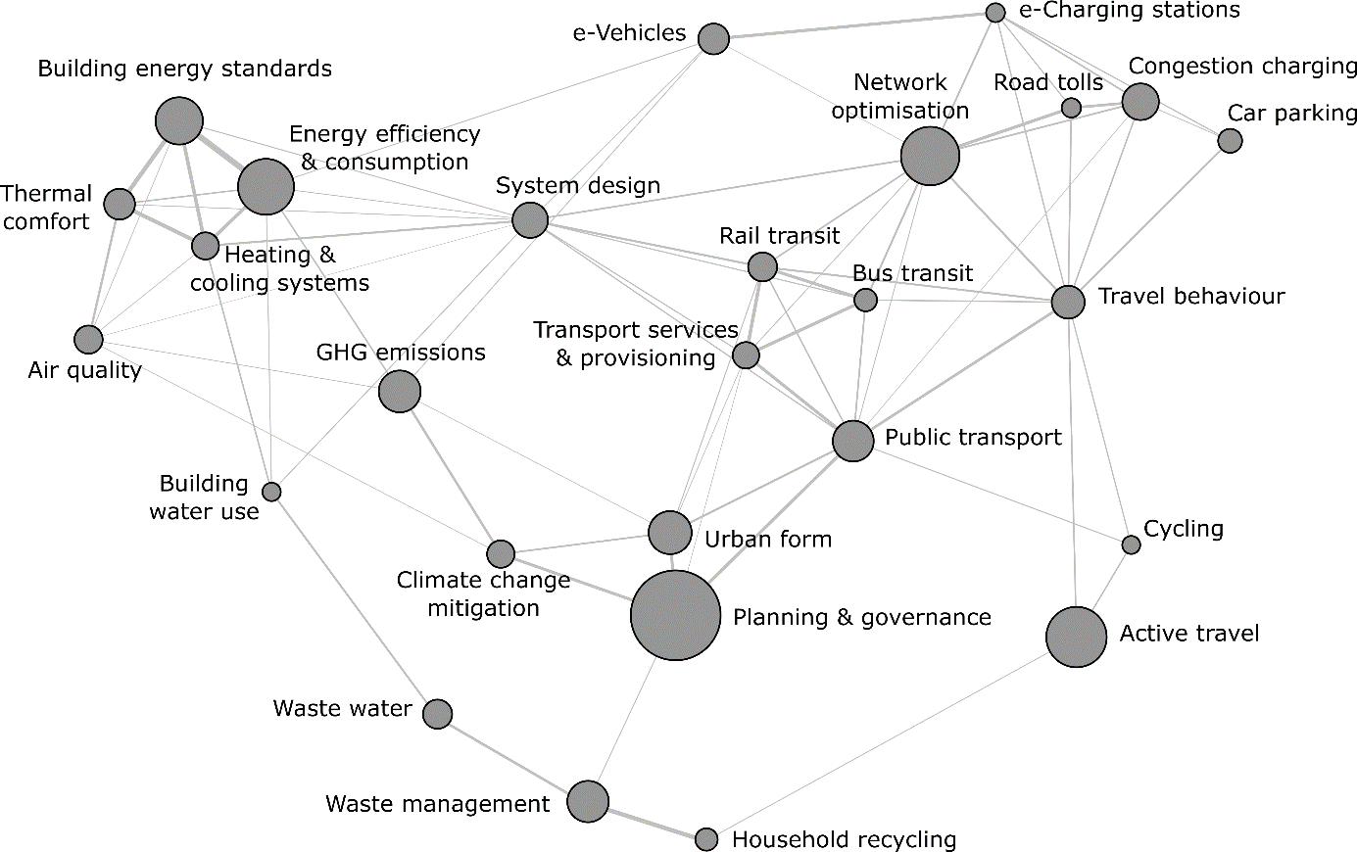

**Figure 3: Correlation structure of urban mitigation topics.** Each node is a topic, scaled by the marginal distribution (see Table 1); each line represents a correlation, based on the co-occurrence of two topics within document abstracts. The highest correlation is 0.3 (between thermal comfort and building energy performance); the lowest is 0.025 (between climate change mitigation and green infrastructure). The visualisation is generated using the force-directed algorithm ForceAtlas2 in Gephi [41].

It is further interesting to note the position and predominance of the topics that directly reference climate issues: climate change mitigation (#18) and GHG emissions (#10). The former is strongly connected to urban form (#6), planning and governance (#1), and policy instruments (#17), but remains relatively abstracted from specific transportation options, waste management, and the buildings literature (although the latter is indeed correlated with building energy performance). This likely reflects a range of competing discourses and priorities in these research areas: for instance, traffic congestion and cost-efficiency in the case of transportation, public health concerns in the case of active travel (#8), or thermal comfort in the case of buildings.

An alternative way to examine this data is to identify bibliographic communities – clusters of documents that cite similar literature – and reveal their topic structure (Figure 4). This confirms the existence of a core set of mitigation papers focused on urban form, planning policy and emissions quantification. A wider periphery of research communities are only indirectly cited by this literature, in particular a large body of work on travel behavior, congestion charging and car parking, but also waste management and active travel.

Using a compiled set of references from the IPCC AR5 Working Group III Report, we find its coverage of the urban mitigation literature that we identify extends to a total of 111 direct citations, out of 9,328 references in the report. This low number should be contextualized within the much broader scope of the relevant chapter (Chapter 12: Human Settlements, Infrastructure, and Spatial Planning), which included many issues not queried here. The topic structure of these citations suggests a predominant focus of the AR5 chapters on documents that are clearly within the “mitigation-core”, related to urban form, building energy consumption, public transportation, or active travel (Supplementary Materials Fig 2).

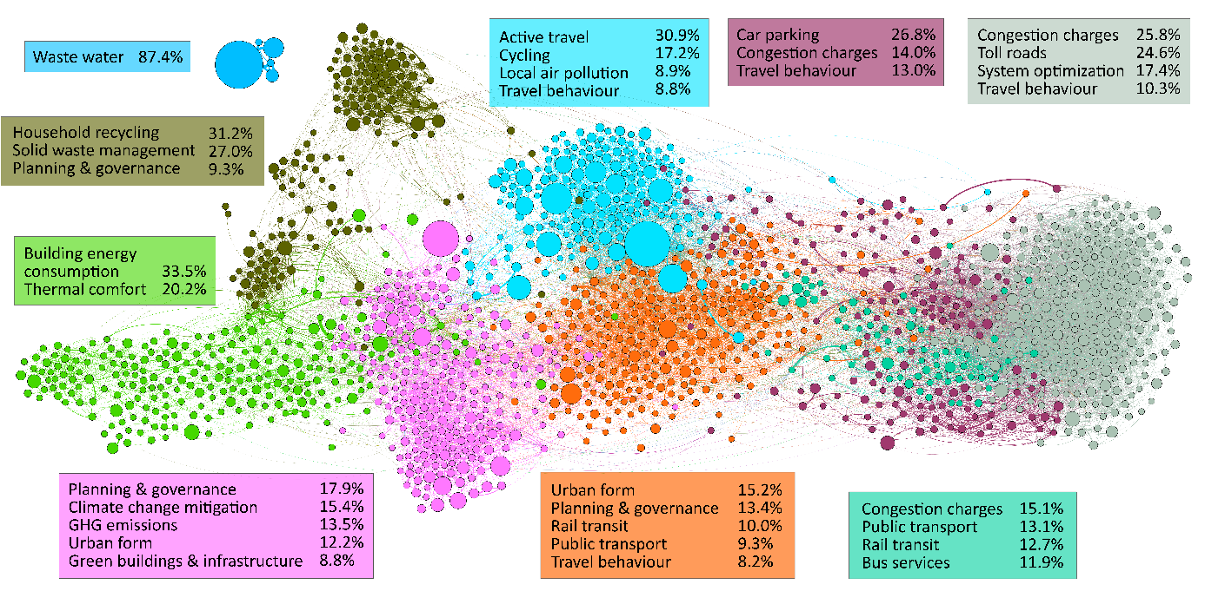

**Figure 4: Bibliographic coupling network of urban mitigation topics.** Nodes represent articles (scaled by total citations), edges represent a coupled citation (two nodes citing the same third article). A total of 1500 nodes are shown, with a minimum threshold of 5 coupled citations. Clusters are identified with a community detection algorithm, then compared to the topic model to identify distinct epistemic communities.

Finally, and related to the timescale discussion (Figure 1), we perform a simple search on the document abstracts to identify years that are associated with projections or scenarios (extracting any 4 digit integers within the range 2020-2100). Where sufficient data is available, the average timescales ranged between 2020 and 2040, increasing to the upper end of this range for the topic cluster on urban form and planning and governance, and decreasing towards 2020 for waste management, building energy performance, and e-Vehicles. The sparse timescales beyond 2050 suggest little in the way of medium and long-term planning, even for topics related to fixed infrastructures.

**Discussion and conclusion**

It is the mandate of the IPCC to provide comprehensive, objective, open and transparent assessments of the available scientific literature on climate change [42]. We have argued elsewhere [17] that it will be increasingly challenging to fulfill this mandate in times of exponentially growing literature, unless there is real innovation in assessment practices. Experts selected by the IPCC themselves no longer have a comprehensive overview of the field – even as a group. In recognition of these new challenges, we delineate a literature corpus on urban climate change mitigation for the upcoming special report on the 1.5°C limit based on a transparent search query. This is a crucial precondition for any comprehensive scientific assessment, yet commonly neglected in practice. While there are many different ways in which this query could have been constructed, we aim to stimulate discussion on such fundamental questions and provide a basic resource to IPCC authors.

We find a total number of 8,210 publications growing annually at 20.5%. This is faster than the average expansion of the scientific enterprise as well as the climate change literature as a whole [17,43,44]. Our estimates do not reflect the entirety of the relevant literature for IPCC assessments due to our focus on: (1) energy demand and waste sectors alone; (2) a narrow interpretation of climate change mitigation that does not systematically consider wider sustainable development issues (Figure 2) that inevitably shape the mitigation solution space [45]; (3) the ISI Web of Science database, which only incompletely covers peer-reviewed and grey literature. Nevertheless, our sample is broadly representative in terms of the thematic structure of the available research.

We apply machine learning algorithms to digest the large amount of information in this corpus and map-out its topic landscape. An unexpected result is the lack of a behavioural aspect to the buildings literature, despite the breadth of individual options that are indeed available [23,46]; this suggests that such literatures are assessed independently of the building context and are therefore not captured by our query. Similarly, the lack of a strong policy theme in the buildings literature, as compared to transportation, may be explained by the differences in governance structures and the intricacies of policy implementation at different scales. Whereas the former is likely to comprise a different set of nationally articulated measures (standards, codes, certificates), with corresponding burdens in terms of institutional and capacity requirements, the latter can be more easily regulated in the urban context of planning, zoning and targeted investment.

On the other hand, the embeddedness of building design and use within urban form and transportation systems has been largely overlooked so far. This is evident in the trade-offs between urban density (which enhances transportation and infrastructure efficiency and implies reduced floor space per capita) and building size (increasing height becomes more costly in terms of materials and energy flows). In addition, public transit corridors, such as bus rapid transit, placed adjacent to new affordable housing developments provide residents with an accessible mobility option *before* they have purchased a personal vehicle, which has the potential to induce preferences and habits favoring public transportation that last for the medium to long term. This indicates an important future direction of research that would consider the additional mitigation benefits from integrated land-use and transport planning [47–50], instead of focusing on sector specific options only. Mitigating to 1.5 will require interaction and linkages across multiple urban dimensions – and this is especially true in places with rapidly growing cities.

Finally, it is striking that the vast majority of relevant research is not framed in terms of urban climate change mitigation, but rather more sector-specific discussions on policy measures for energy demand reduction. Apparently the topic of urban climate change policies is just emerging, which is not surprising as there are still very few comparable emissions data available at the city scale [8,11] – particularly as large N samples [16,20,51–53].

We show that some topics have been better captured than others in AR5. While there might be very good reasons for those choices, we argue that systematic mappings of the literature landscape could help make assessment choices transparent and at the same time ensure that none of the major topics are neglected. We further note the availability of multiple reviews – a total of 372 in our literature corpus – that can be easily identified. In times when primary studies can no longer be comprehensively assessed within the IPCC, it seems absolutely key for the organization to explicitly prioritize the systematic assessment of these where available. We provide these reviews by topic, as well as the full document list, as a resource in the supplementary material.

Although there is yet to emerge a literature specific to cities and the 1.5°C target, this goal requires, fundamentally, a broadening of the policy space to harness all available mitigation options across governance scales. The challenge of the IPCC Special Report is therefore to examine a much wider array of literature than otherwise might be considered. Literatures that ought not to be overlooked are those that examine mitigation options in the building, transportation and waste sectors, and through urban form. Only a systematic and transparent approach will uncover their potential and pave the way for meaningful entry points into deep and lasting urban climate change mitigation.

1. Rogelj J, Luderer G, Pietzcker RC, Kriegler E, Schaeffer M, Krey V, Riahi K: **Energy system transformations for limiting end-of-century warming to below 1.5 °C** . *Nat. Clim. Chang.* 2015, **5**:519–527.

2. Luderer G, Pietzcker RC, Bertram C, Kriegler E, Meinshausen M, Edenhofer O: **Economic mitigation challenges: how further delay closes the door for achieving climate targets**. *Environ. Res. Lett.* 2013, **8**:34033.

3. Clarke L, Jiang K, Akimoto K, Babiker M, Blanford G, Fisher-Vanden K, Hourcade JC, Krey V, Kriegler E, Loschel A, et al.: **Assessing transformation pathways**. In *Climate Change 2014: Mitigation of Climate Change. Contribution of Working Group III to the Fifth Assessment Report of the Intergovernmental Panel on Climate Change*. Edited by Edenhofer O, Pichs-Madruga R, Sokona Y, Farahani E, Kadner S, Seyboth A, Adler A, Baum I, Brunner S, Eickemeier P, et al. Cambridge University Press; 2014.

4. IPCC: **Summary for Policymakers**. In *Climate Change 2014: Mitigation of Climate Change. Contribution of Working Group III to the Fifth Assessment Report of the Intergovernmental Panel on Climate Change*. Edited by Edenhofer O, Pichs-Madruga R, Sokona Y, Farahani E, Kadner S, Seyboth K, Adler A, Baum I, Brunner S, Eickemeier P, et al. Cambridge University Press; 2014:1–33.

5. Creutzig F, Agoston P, Minx JC, Canadell JG, Andrew RM, Quéré C Le, Peters GP, Sharifi A, Yamagata Y, Dhakal S: **Urban infrastructure choices structure climate solutions**. *Nat. Clim. Chang.* 2016, **6**:1054.

6. Müller DB, Liu G, Løvik AN, Modaresi R, Pauliuk S, Steinhoff FS, Brattebø H: **Carbon Emissions of Infrastructure Development**. *Environ. Sci. Technol.* 2013, doi:10.1021/es402618m.

7. Erickson P, Tempest K: *Keeping cities green: Avoiding carbon lock-in due to urban development*. 2015.

8. Karen C. S, Dhakal S, Bigio A, Blanco H, Delgado GC, Dewar D, Huang L, Inaba A, Kansal A, Lwasa S, et al.: **Human Settlements, Infrastructure, and Spatial Planning**. In *Climate Change 2014: Mitigation of Climate Change. Contribution of Working Group III to the Fifth Assessment Report of the Intergovernmental Panel on Climate Change*. . Cambridge University Press; 2014:923–1000.

9. Seto K, Dhakal S, Bigio AG, Blanco H, Delgado GC, Dewar D, Huang L, Inaba A, Kansal A, Lwasa S, et al.: **Chapter 12: Human Settlements, Infrastructure, and Spatial Planning**. *Clim. Chang. 2014 Mitig. Clim. Chang. Contrib. Work. Gr. III to Fifth Assess. Rep. Intergov. Panel Clim. Chang.* 2014.

10. Somanthan E, Sterner T, Sugiyama T, Chimanikire D, Dubash NK, Essandoh-Yeddu J, Fifita S, Goulder L, Jaffe A, Labandeira X, et al.: **National and Sub-national Policies and Institutions**. In *Climate Change 2014: Mitigation of Climate Change. Contribution of Working Group III to the Fifth Assessment Report of the Intergovernmental Panel on Climate Change*. Edited by Edenhofer O, Pichs-Madruga R, Sokona Y, Farahani E, Kadner S, Seyboth K, Adler A, Baum I, Brunner S, Eickemeier P, et al. Cambridge University Press; 2014:1141–1206.

11. Grubler A, Bai X, Buettner T, Dhakal S, Fisk D, Ichinose T, Keristead J, Sammer G, Satterthwaite D, Schulz N, et al.: **Urban Energy Systems**. In *Global Energy Assessment - Toward a Sustainable Future*. . International Institute for Applied Systems Analysis and Cambridge University Press; 2012:1307–1400. **[*First assessment on cities that attempts to gather global data on energy use, providing the ground for further structured investigations of urban climate drivers on global scale (ref 16,19).]**

12. IPCC: *Decision IPCC/XLIV-4. Sixth Assessment Report (AR6) Products, Outline of the Special Report on 1.5°C*. 2018.

13. Wilson C, Grubler A, Gallagher KS, Nemet GF: **Marginalization of end-use technologies in energy innovation for climate protection**. *Nat. Clim. Chang.* 2012, **2**:780–788.

14. Creutzig F: **Evolving Narratives of Low-Carbon Futures in Transportation**. *Transp. Rev.* 2016, **36**:341–360.

15. O’Neill BC, Dalton M, Fuchs R, Jiang L, Pachauri S, Zigova K: **Global demographic trends and future carbon emissions**. *Proc. Natl. Acad. Sci. U. S. A.* 2010, **107**:17521–6.

16. Creutzig F, Baiocchi G, Bierkandt R, Pichler P-P, Seto KC: **Global Typology of Urban Energy Use and Potentials for an Urbanization Mitigation Wedge**. *Proc. Natl. Acad. Sci.* 2015, **112**:6283–6288.

17. Minx JC, Callaghan MW, Lamb WF, Garard J, Edenhofer O: **Learning about climate change solutions in the IPCC and beyond**. *Environ. Sci. Policy* 2017, [in press]. **[** Points out that the ongoing literature explosion requires novel systematic tools for literature analysis in assessments.]**

18. Rosenzweig C, Solecki W, Romero-lankao P, Mehrotra S, Dhakal S, Bowman T, Ibrahim SA: *ARC3.2 Summary for City Leaders Climate Change and Cities: Second Assessment Report of the Urban Climate Change Research Network*. Columbia University; 2015.

19. Marcotullio PJ, Sarzynski A, Albrecht J, Schulz N, Garcia J: **The geography of global urban greenhouse gas emissions: an exploratory analysis**. *Clim. Change* 2013, doi:10.1007/s10584-013-0977-z.

20. Minx J, Baiocchi G, Wiedmann T, Barrett J, Creutzig F, Feng K, Förster M, Pichler P-P, Weisz H, Hubacek K: **Carbon footprints of cities and other human settlements in the UK**. *Environ. Res. Lett.* 2013, **8**:35039.

21. Gurney KR, Romero-Lankao P, Seto KC, Hutyra LR, Duren R, Kennedy C, Grimm NB, Ehleringer JR, Marcotullio P, Hughes S, et al.: **Climate change: Track urban emissions on a human scale**. *Nature* 2015, **525**:179–181.

22. Blei DM: **Probabilistic Topic Models**. *Commun. ACM* 2012, **55**:77–84.

23. Creutzig F, Fernandez B, Haberl H, Khosla R, Mulugetta Y, Seto KC: **Beyond Technology: Demand-Side Solutions to Climate Change Mitigation**. *Annu. Rev. Environ. Resour.* 2016, **41**. **[**Finds significant mitigation potential on the demand side, most of which to be realized on urban scale.]**

24. Mattauch L, Ridgway M, Creutzig F: **Happy or liberal? Making sense of behavior in transport policy design**. *Transp. Res. Part D Transp. Environ.* 2016, **45**:64–83.

25. Weinberger R, Goetzke F: **Unpacking preference: How previous experience affects auto ownership in the United States**. *Urban Stud.* 2010. **[*Reveals the importance of endogenous preferences in residential and transport choice.]**

26. Ewing R, Cervero R: **Travel and the Built Environment -- A Meta-Analysis**. *J. Am. Plan. Assoc.* 2010, **76**:265–294.

27. IEA: *Energy technology perspective - Towards sustainable urban energy systems*. 2016.

28. Grubler A, Fisk D: *Energizing Sustainable Cities: Assessing Urban Energy*. Routledge; 2013.

29. Salon D, Boarnet MG, Handy S, Spears S, Tal G: **How do local actions affect VMT? A critical review of the empirical evidence**. *Transp. Res. Part D Transp. Environ.* 2012, **17**:495–508.

30. Bongardt D, Breithaupt M, Creutzig F: **Beyond the fossil city: Towards low carbon transport and green growth**. In *5th regional environmentally sustainable transport forum in Asia, United Nations Centre for Regional Development, Bangkok, Thailand*. 2010. **[**Overview of policy options in urban transport.]**

31. Bongardt D, Creutzig F, Hüging H, Sakamoto K, Bakker S, Gota S, Böhler-Baedeker S: *Low-carbon land transport: policy handbook*. Routledge; 2013.

32. Ürge-Vorsatz D, Novikova A: **Potentials and costs of carbon dioxide mitigation in the world’s buildings**. *Energy Policy* 2008, **36**:642–661. **[*Breaks ground on systematically assessing the building sector's potential to climate mitigation.]**

33. Lucon O, Ürge-Vorsatz D, Zain Ahmed A, Akbari H, Bertoldi P, Cabeza LF, Eyre N, Gadgil A, Harvey LDD, Jiang Y, et al.: **Buildings**. In *Climate Change 2014: Mitigation of Climate Change. Contribution of Working Group III to the Fifth Assessment Report of the Intergovernmental Panel on Climate Change [Edenhofer, O., R. Pichs-Madruga, Y. Sokona, E. Farahani, S. Kadner, K. Seyboth, A. Adler,*. . 2014.

34. Ürge-Vorsatz D, et al.: **Energy End-Use: Buildings**. 2012, [no volume].

35. Cabeza LF, Urge-Vorsatz D, McNeil MA, Barreneche C, Serrano S: **Investigating greenhouse challenge from growing trends of electricity consumption through home appliances in buildings [Internet]**. *Renew. Sustain. Energy Rev.* 2014, **36**:188–193.

36. Bajželj B, Richards KS, Allwood JM, Smith P, Dennis JS, Curmi E, Gilligan CA: **Importance of food-demand management for climate mitigation**. *Nat. Clim. Chang.* 2014, **4**:924–929.

37. Lecocq F, Shalizi Z: **The economics of targeted mitigation in infrastructure**. *Clim. Policy* 2014, **14**:187–208.

38. Fujita M: *Urban Economic Theory*. Cambridge University Press; 1989.

39. Creutzig F: **How fuel prices determine public transport infrastructure, modal shares and urban form**. *Urban Clim.* 2014, **10**:63–76.

40. Lee DD, Seung HS: **Learning the parts of objects by non-negative matrix factorization. [Internet]**. *Nature* 1999, **401**:788–91.

41. Jacomy M, Venturini T, Heymann S, Bastian M: **ForceAtlas2, a continuous graph layout algorithm for handy network visualization designed for the Gephi software**. *PLoS One* 2014, **9**:1–12.

42. IPCC: **Appendix A: Procedures for the preparation, review, acceptance, adoption, approval and publication of IPCC Reports**. In *Principles Governing IPCC Work*. . IPCC; 2013.

43. Haunschild R, Bornmann L, Marx W: **Climate Change Research in View of Bibliometrics [Internet]**. *PLoS One* 2016, **11**:e0160393.

44. Grieneisen ML, Zhang M: **The current status of climate change research.** *Nat. Clim. Chang.* 2011, **1**:72–73.

45. von Stechow C, Minx JC, Riahi K, Jewell J, McCollum DL, Callaghan MW, Bertram C, Luderer G, Baiocchi G: **2oC and the SDGs: United they stand, divided they fall?** *Environ. Res. Lett.* 2016, **11**.

46. Sorrell S: **Reducing energy demand: A review of issues, challenges and approaches**. *Renew. Sustain. Energy Rev.* 2015, **47**:74–82.

47. Wegener M: **Overview of land use transport models**. In *Handbook of transport geography and spatial systems*. . Emerald Group Publishing Limited; 2004:127–146. **[**Transport land use models generate many detailed insights that are still insufficiently utilized in the climate mitigation literature.]**

48. Moeckel R, Nagel K: **Maintaining Mobility in Substantial Urban Growth Futures**. *Transp. Res. Procedia* 2016, **19**:70–80.

49. M. W: **Land-use transport interaction models**. In *Handbook of Regional Science*. . Springer; 2014:741–758.

50. Mitchell G, Hargreaves A, Namdeo A, Echenique M: **Land use, transport, and carbon futures: the impact of spatial form strategies in three UK urban regions**. *Environ. Plan. A* 2011, **43**:2143–2163.

51. Baiocchi G, Creutzig F, Minx J, Pichler PP: **A spatial typology of human settlements and their CO2 emissions in England**. *Glob. Environ. Chang.* 2015, **34**:13–21.

52. Markolf SA, Matthews HS, Azevedo IL, Hendrickson C: **An integrated approach for estimating greenhouse gas emissions from 100 U.S. metropolitan areas**. *Environ. Res. Lett.* 2017, **12**.

53. Minx JC: **Better data for assessing local climate policies**. *Environ. Res. Lett.* 2017, **12**.

1. To be clear, each document is a combination of topics, hence the prevalence of this particular topic across the whole corpus.